Movement Description Words
# Source: AI Source: Provided by: [Data Path: Persons Table -> ID Column: 1, Name_En Column: Motasem Essam] -> From: [ChatGPT] on [7/17/2026]
Movement Description Words are terms used to describe how an object or living thing moves. They explain the direction, speed, pattern, and nature of motion and are commonly used in physics, mathematics, engineering, transportation, sports, and everyday language.
These words help describe movement accurately and consistently.

Definition
# Source: AI Source: Provided by: [Data Path: Persons Table -> ID Column: 1, Name_En Column: Motasem Essam] -> From: [ChatGPT] on [7/17/2026]
Movement Description Words are descriptive terms used to explain the way an object changes its position, direction, speed, or motion over time.

Categories of Movement Description Words

1. Speed Description
# Source: AI Source: Provided by: [Data Path: Persons Table -> ID Column: 1, Name_En Column: Motasem Essam] -> From: [ChatGPT] on [7/17/2026]
Describes how fast or slow something moves.
Examples:
- Fast
- Slow
- Rapid
- Quick
- Gradual
- Swift
- Steady
- Constant
- Accelerating
- Decelerating

2. Direction Description
# Source: AI Source: Provided by: [Data Path: Persons Table -> ID Column: 1, Name_En Column: Motasem Essam] -> From: [ChatGPT] on [7/17/2026]
Describes where something moves.
Examples:
- Up
- Down
- Left
- Right
- Forward
- Backward
- North
- South
- East
- West
- Inward
- Outward

3. Motion Pattern
# Source: AI Source: Provided by: [Data Path: Persons Table -> ID Column: 1, Name_En Column: Motasem Essam] -> From: [ChatGPT] on [7/17/2026]
Describes the shape or path of movement.
Examples:
- Straight
- Curved
- Circular
- Rotational
- Spiral
- Zigzag
- Oscillating
- Wavy
- Random

4. Position Change
# Source: AI Source: Provided by: [Data Path: Persons Table -> ID Column: 1, Name_En Column: Motasem Essam] -> From: [ChatGPT] on [7/17/2026]
Describes movement relative to a reference point.
Examples:
- Approaching
- Receding
- Entering
- Leaving
- Crossing
- Passing
- Returning
- Departing
- Arriving

5. Vertical Movement
# Source: AI Source: Provided by: [Data Path: Persons Table -> ID Column: 1, Name_En Column: Motasem Essam] -> From: [ChatGPT] on [7/17/2026]
Examples:
- Rising
- Falling
- Ascending
- Descending
- Lifting
- Dropping

6. Rotational Movement
Examples:
- Rotating
- Turning
- Spinning
- Twisting
- Revolving

7. Repeated Movement
Examples:
- Vibrating
- Oscillating
- Swinging
- Bouncing
- Pulsing

8. Starting and Stopping
# Source: AI Source: Provided by: [Data Path: Persons Table -> ID Column: 1, Name_En Column: Motasem Essam] -> From: [ChatGPT] on [7/17/2026]
Examples:
- Starting
- Beginning
- Moving
- Continuing
- Pausing
- Stopping
- Halting
- Restarting

Common Verbs of Movement
# Source: AI Source: Provided by: [Data Path: Persons Table -> ID Column: 1, Name_En Column: Motasem Essam] -> From: [ChatGPT] on [7/17/2026]
Examples include:
- Walk
- Run
- Jump
- Crawl
- Climb
- Slide
- Roll
- Swim
- Fly
- Drive
- Ride
- Drift
- Float
- Glide
- Spin

Adverbs Describing Movement
# Source: AI Source: Provided by: [Data Path: Persons Table -> ID Column: 1, Name_En Column: Motasem Essam] -> From: [ChatGPT] on [7/17/2026]
These describe how movement occurs.
Examples:
- Slowly
- Quickly
- Smoothly
- Carefully
- Suddenly
- Gently
- Rapidly
- Quietly
- Continuously
- Instantly

Opposite Movement Words
# Source: AI Source: Provided by: [Data Path: Persons Table -> ID Column: 1, Name_En Column: Motasem Essam] -> From: [ChatGPT] on [7/17/2026]
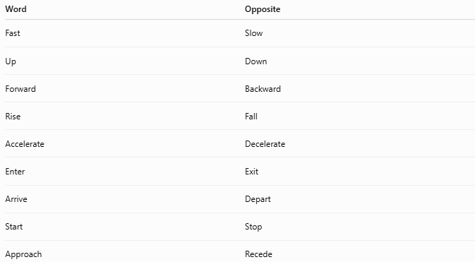
Word | Opposite
Fast | Slow
Up | Down
Forward | Backward
Rise | Fall
Accelerate | Decelerate
Enter | Exit
Arrive | Depart
Start | Stop
Approach | Recede

Examples in Sentences
# Source: AI Source: Provided by: [Data Path: Persons Table -> ID Column: 1, Name_En Column: Motasem Essam] -> From: [ChatGPT] on [7/17/2026]
- The car accelerated rapidly.
- The balloon rose into the sky.
- The Earth rotates on its axis.
- The train moved forward.
- The pendulum oscillated continuously.
- The child walked slowly across the room.
- The airplane descended for landing.

Applications
# Source: AI Source: Provided by: [Data Path: Persons Table -> ID Column: 1, Name_En Column: Motasem Essam] -> From: [ChatGPT] on [7/17/2026]
Movement description words are used in:
- Physics
- Mathematics
- Engineering
- Robotics
- Transportation
- Sports
- Geography
- Computer animation
- Everyday communication

Importance
# Source: AI Source: Provided by: [Data Path: Persons Table -> ID Column: 1, Name_En Column: Motasem Essam] -> From: [ChatGPT] on [7/17/2026]
These words help:
- Describe motion accurately.
- Explain scientific observations.
- Communicate directions.
- Analyze physical systems.
- Improve technical writing.

Common Mistakes
# Source: AI Source: Provided by: [Data Path: Persons Table -> ID Column: 1, Name_En Column: Motasem Essam] -> From: [ChatGPT] on [7/17/2026]
- Confusing speed with direction.
- Using rotation instead of revolution.
- Assuming fast always means accelerating (an object can move fast at a constant speed).
- Mixing up ascending and approaching.

Interesting Facts
# Source: AI Source: Provided by: [Data Path: Persons Table -> ID Column: 1, Name_En Column: Motasem Essam] -> From: [ChatGPT] on [7/17/2026]
- Scientists often combine descriptive words with measurable quantities such as velocity, acceleration, and displacement.
- The same movement may be described using multiple words. For example, a satellite can orbit, revolve, and move in a circular path.

Summary Table
# Source: AI Source: Provided by: [Data Path: Persons Table -> ID Column: 1, Name_En Column: Motasem Essam] -> From: [ChatGPT] on [7/17/2026]
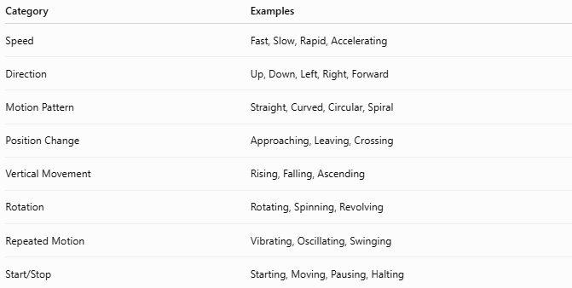
Category | Examples
Speed | Fast, Slow, Rapid, Accelerating
Direction | Up, Down, Left, Right, Forward
Motion Pattern | Straight, Curved, Circular, Spiral
Position Change | Approaching, Leaving, Crossing
Vertical Movement | Rising, Falling, Ascending
Rotation | Rotating, Spinning, Revolving
Repeated Motion | Vibrating, Oscillating, Swinging
Start/Stop | Starting, Moving, Pausing, Halting

Key Points
# Source: AI Source: Provided by: [Data Path: Persons Table -> ID Column: 1, Name_En Column: Motasem Essam] -> From: [ChatGPT] on [7/17/2026]
- Movement description words explain how objects move.
- They describe:
  - Speed
  - Direction
  - Motion pattern
  - Position changes
  - Rotation
  - Repeated motion
- They are widely used in science, engineering, transportation, and everyday life.

Conclusion
# Source: AI Source: Provided by: [Data Path: Persons Table -> ID Column: 1, Name_En Column: Motasem Essam] -> From: [ChatGPT] on [7/17/2026]
Movement Description Words provide the vocabulary needed to describe motion clearly and precisely. Whether explaining how an object moves, changes direction, speeds up, slows down, rotates, or follows a particular path, these terms are fundamental in physics, mathematics, engineering, and everyday communication. They complement quantitative measurements by giving meaningful descriptions of motion that help people observe, analyze, and communicate movement effectively.

